**Forensic Oceanography Statistical Annex**

**1. Recorded migrant death and arrivals**

Data sources:

Arrivals: UNHCR data based on the agency’s border activities, Ministry of Interior and Police data. Data available at: <http://data.unhcr.org/mediterranean/regional.php>

Recorded deaths: IOM, collected on the basis of statistical data from governments and other agencies, as well as NGOs and media. Available at: <http://missingmigrants.iom.int/mediterranean>

*Central Mediterranean*

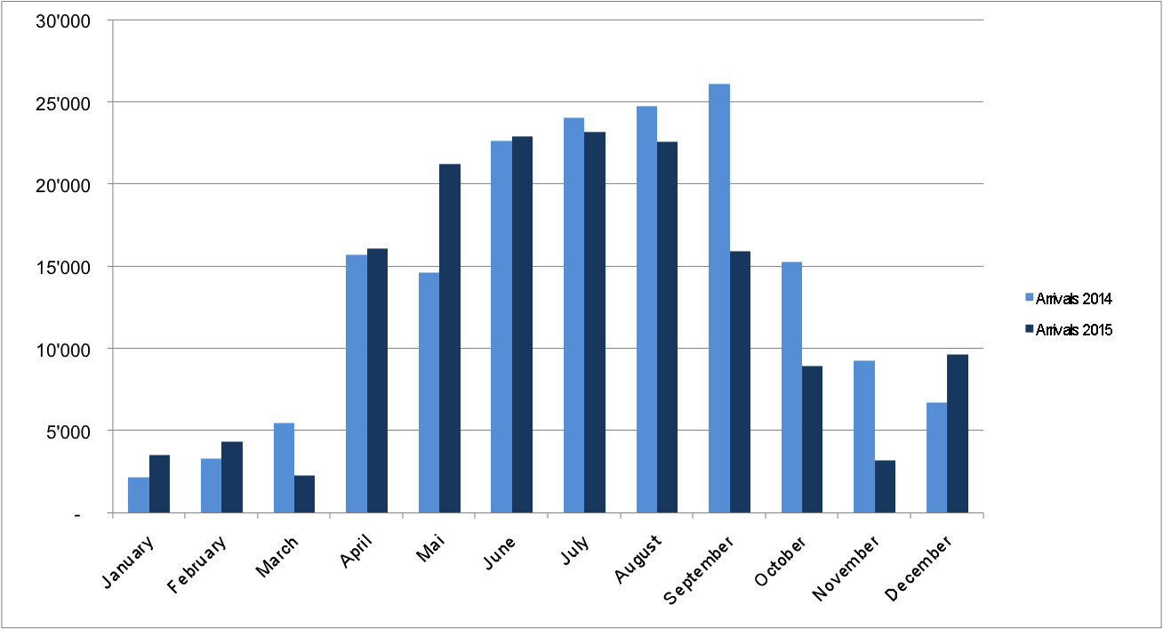

Migrant arrivals in the central Mediterranean, 2014-5 (Based on UNHCR data)

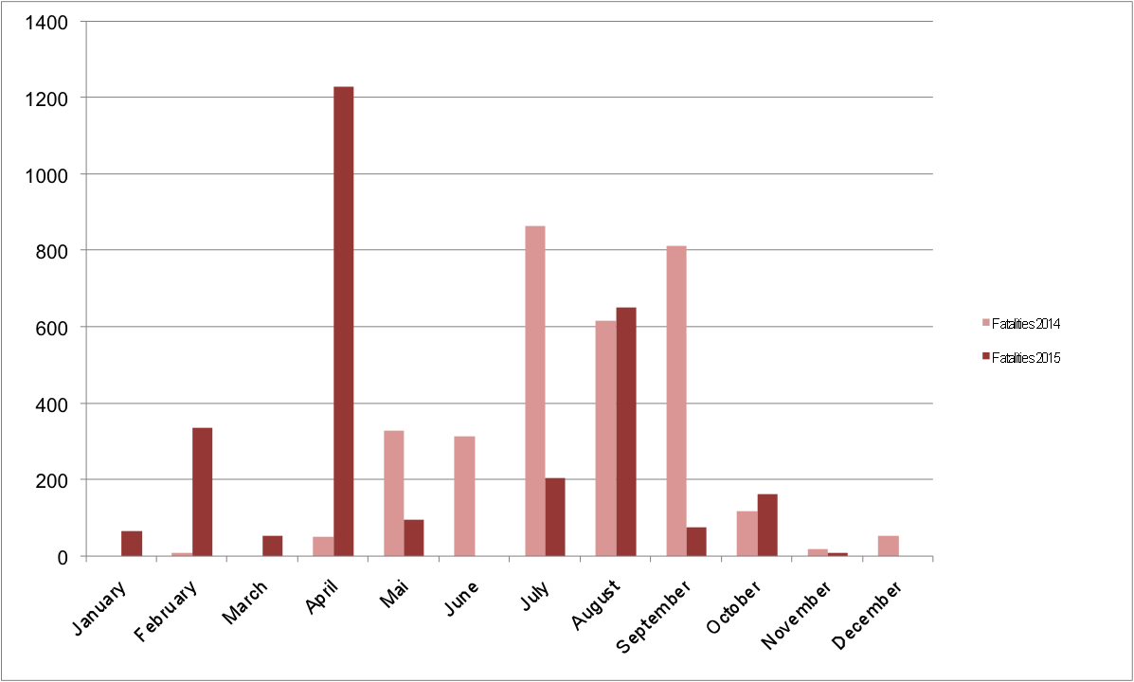

Migrant deaths in the central Mediterranean, 2014-5 (Based on IOM data)

*Eastern Mediterranean*

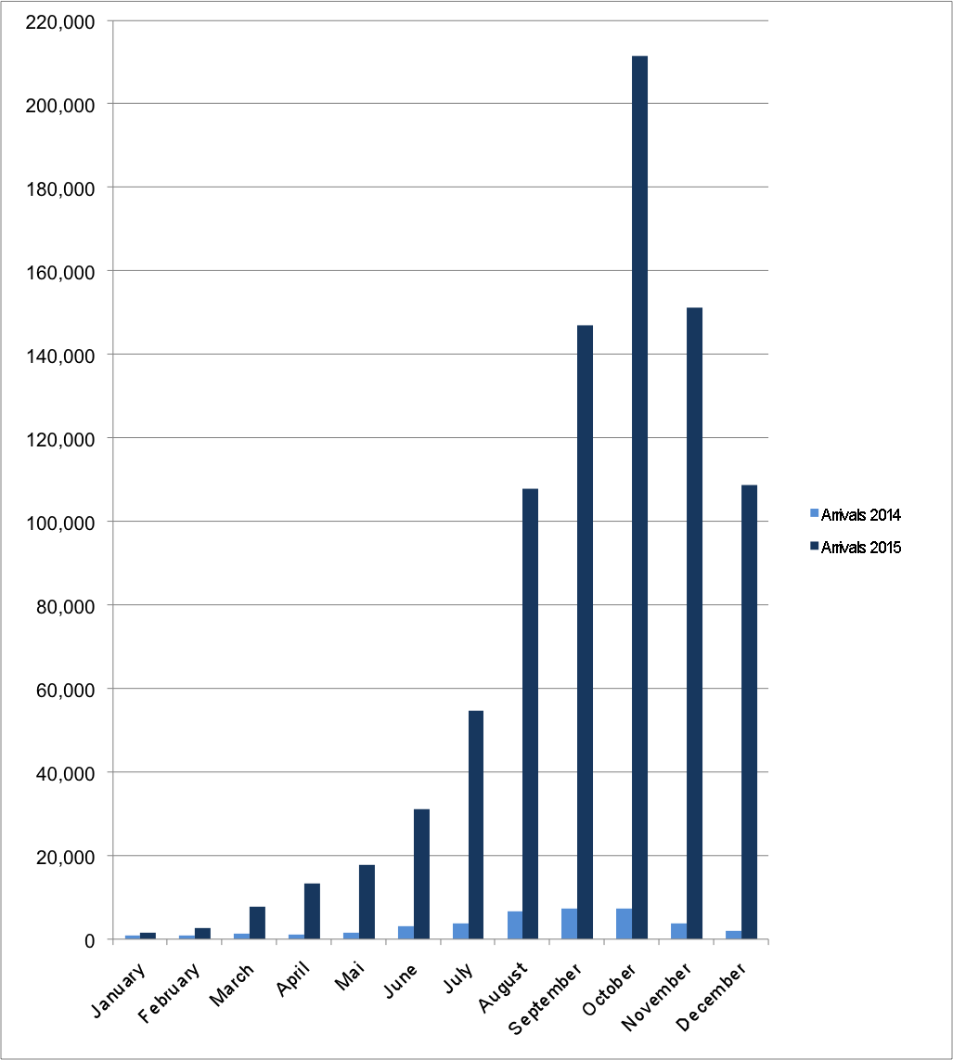

Migrant arrivals in the eastern Mediterranean, 2014-5 (Based on UNHCR data)

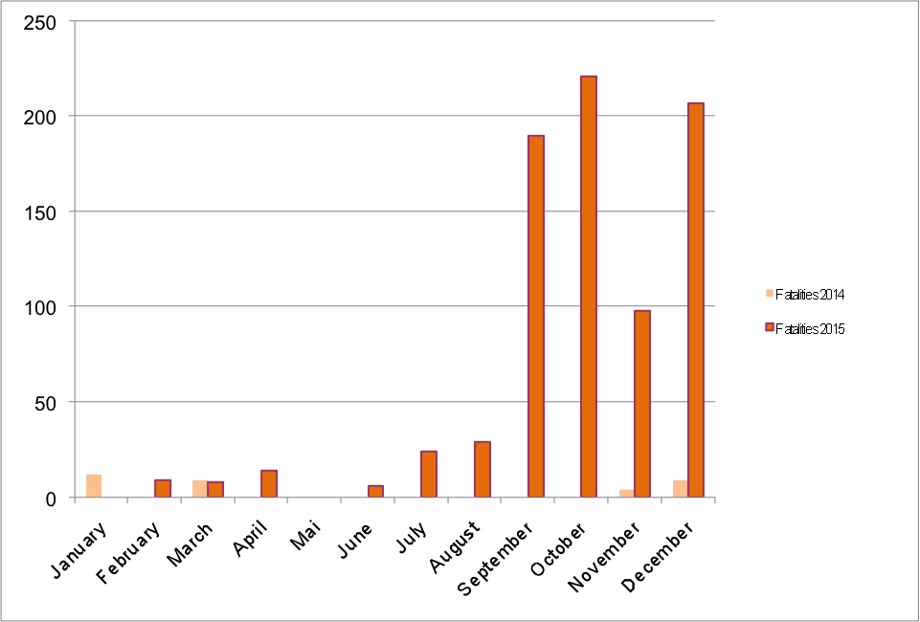

Migrant deaths in the eastern Mediterranean, 2014-5 (Based on IOM data)

**2. Migrant mortality rate**

*Methodology*

A mortality rate is a measure of the number of deaths in a particular population per unit of time. To calculate the migrant mortality rate (MMR) which we can understand as a measure of the danger of crossing the sea, we calculate the proportion of migrants dying in relation to number of migrants who initially left (the sum of the live arrivals and deaths at sea). However, because neither all arrivals nor all fatalities are discovered in relation to illegalised migration – a phenomena that operates by definition in a partially hidden way –, the calculation of mortality based on *recorded* arrivals and deaths is by necessity incomplete.[1] Even though at present the Mediterranean is a highly monitored space and we can thus expect most deaths and arrivals to be recorded in the sources we rely on (UNHCR for arrivals and IOM for deaths), to date, no satisfactory solution to this methodological issue has been applied to migrant mortality at sea. As such the mortality rate calculated for this report should be seen as *indicative of tendencies* of the increasing or decreasing danger of crossing rather than a highly reliable measure.

|  |  |  |  |  |
| --- | --- | --- | --- | --- |
|  | **Central Med** | **Eastern Med** | **Western Med** | **Total Med** |
| Fatalities 2014 | 3186 | 34 | 34 | 3254 |
| Arrivals 2014 | 170'100 | 41038 | 4'348 | 215'486 |
| **MMR 2014** | **18.4** | **1** | **8** | **15** |
|  |  |  |  |  |
| Fatalities 2015 | 2892 | 806 | 72 | 3770 |
| Arrivals 2015 | 153'842 | 856'723 | 4'408 | 1'014'973 |
| **MMR 2015** | **18.5** | **0.9** | **16.1** | **3.7** |

Annual fatalities, arrivals and migrant mortality rate (MMR) in the different areas of the Mediterranean, 2014-2015 (based on UNHCR and IOM data).

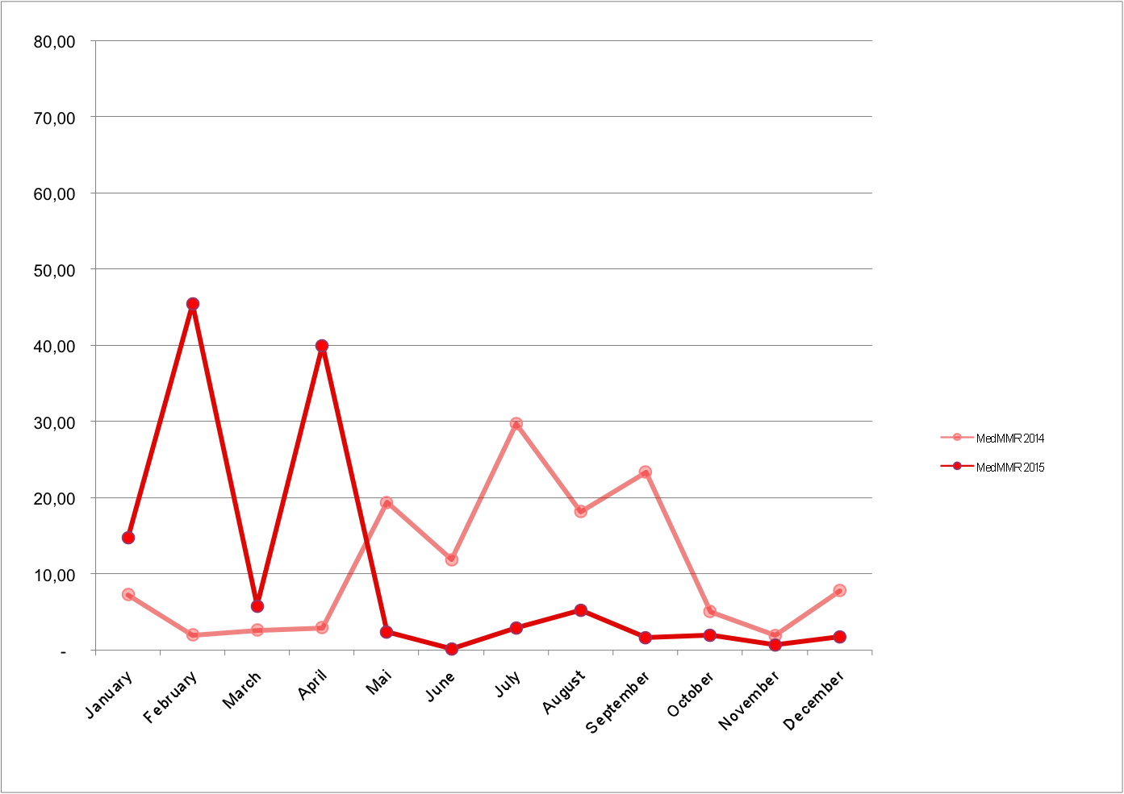

Migrant mortality rate in the Mediterranean, 2014-5 (based on UNHCR and IOM data).

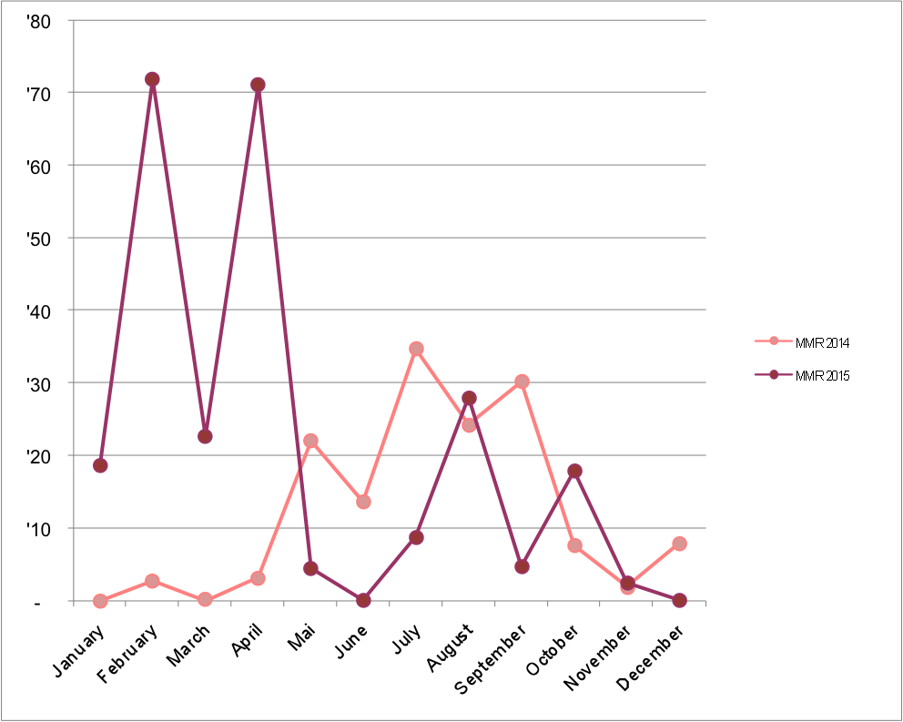

Migrant mortality rate in the central Mediterranean, 2014-5 (based on UNHCR and IOM data).

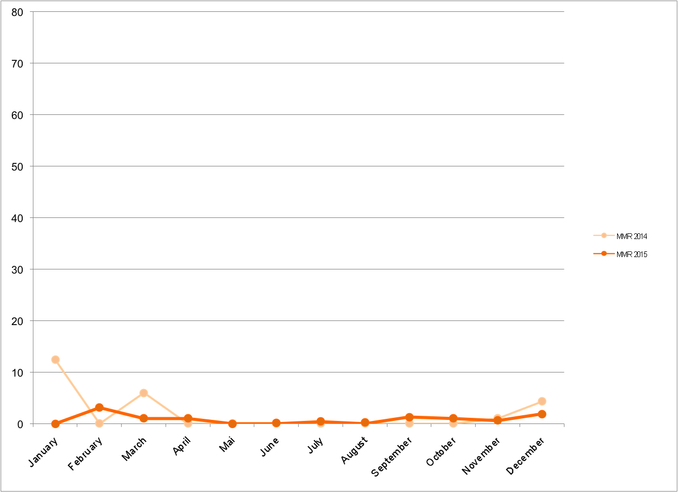

Migrant mortality rate in the eastern Mediterranean, 2014-5 (based on UNHCR and IOM data).

**3. Interception/Rescue operations by actor in the central Mediterranean**

Data source: Italian Coast Guard

*2014 data*

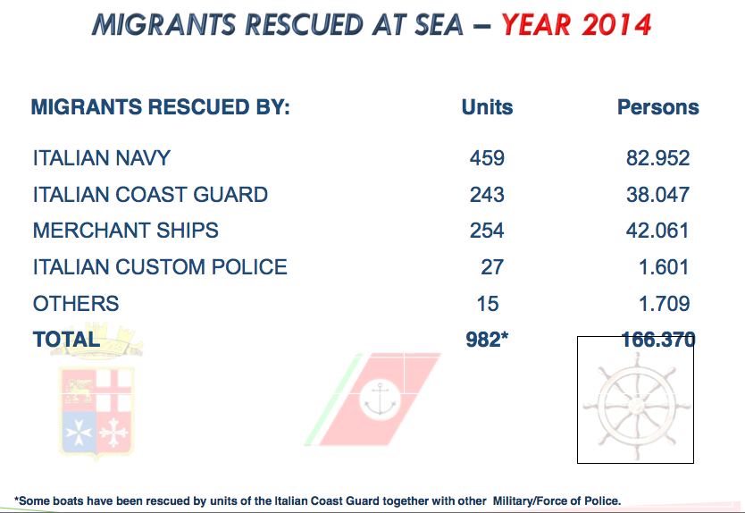

Migrants rescued by actor in the central Mediterranean, 2014 (Italian Coast Guard data)

*2015 data*

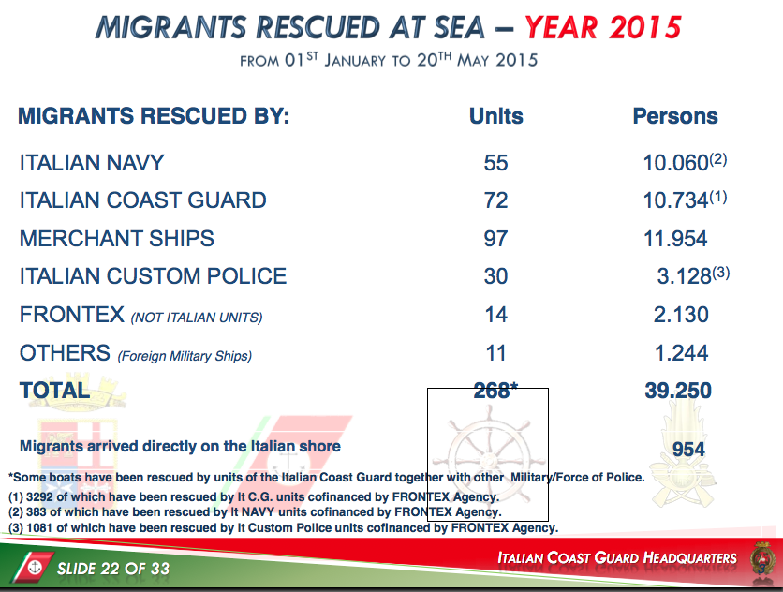

Migrants rescued by actor in the central Mediterranean, up to 20th May 2015 (Italian Coast Guard data)

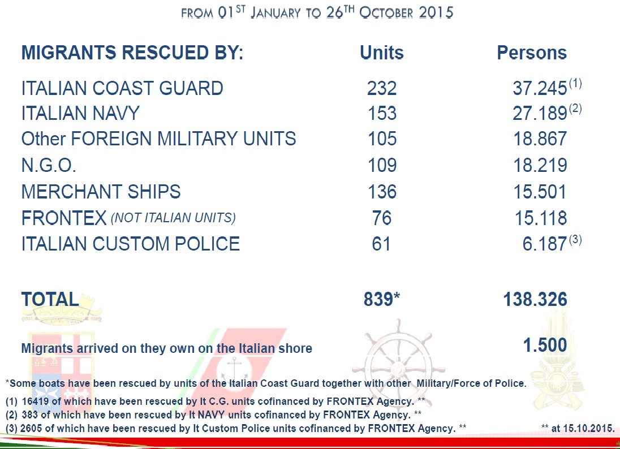

Migrants rescued by actor in the central Mediterranean, up to 26th October 2015 (Italian Coast Guard data)

1. Jørgen Carling, “Migration Control and Migrant Fatalities at the Spanish-African Borders.” *IMR* 41, no. 2, 2007, pp. 316-343; Tamara Last and Thomas Spijkerboer, “Tracking deaths in the Mediterranean”, In Tara Brian and Frank Laczko, eds. *Fatal Journeys: Tracking Lives Lost during Migration*, International Organisation of Migration, 2014.